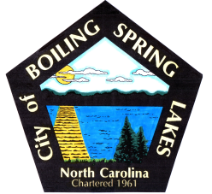 | City of Boiling Spring Lakes  9 East Boiling Spring Road  Boiling Spring Lakes, NC 28461

Special Events Committee
October 8, 2025
5:30 P.M.
City Hall

AGENDA

- Call to Order

- Approval of Agenda

- Approval of Minutes

- Public Comment

- Budget Report

- Old Business

a. Halloween Fall Festival
b. Candidates Forum

- New Business

- City Christmas Tree Lighting
- Christmas

- Announcements

- Next Meeting Agenda Items

- Adjournment

