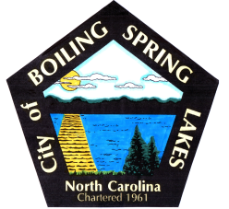 | City of Boiling Spring Lakes  9 East Boiling Spring Road  Boiling Spring Lakes, NC 28461

Special Events Committee
July 9, 2025
5:30 p.m.
City Hall

AGENDA

I. Call to Order

II. Approval of Agenda

III. Approval of Minutes

IV. Public Comment

V. Budget Report

VI. Old Business

VII. New Business

a. Mayor’s Cup Tournament wrap-up

VIII. Announcements/Discussion

IX. Adjournment

