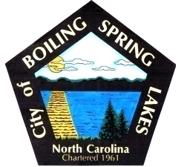 | City of Boiling Spring Lakes  9 East Boiling Spring Road  Boiling Spring Lakes, NC 28461

Parks and Recreation Advisory Board
Wednesday, July 16, 2025
6:00 P.M.

AGENDA

- Call to Order
- Introductions
- Approval of Agenda
- Approval of Minutes
- Director’s Monthly Report
- Standing Committee Reports
  - Review of Committee Responsibilities
    - Communications
    - Facilities
    - Department
- Public Comments
- Old Business/remove or hold
  - ADA Compliance
    - Accessibility
    - Hearing loss
  - Support for the P&R department 2025 goals
  - Review of Master Plan
  - Dog park interest
  - Subcommittee for creation of Venus Flytrap Nature trail and next steps
- New Business
  - Written Board policies and procedures
- Agendas, Secretary Minutes, Committee, Director written Reports
  - Monthly BOC presentations schedule/report
  - Reporting schedule with phone numbers and email addresses
  - Vacancy on P & R Advisory Board
- Next meeting agenda Items
  - Update Registered Agent for BSL Friends of P & R Inc.
- Announcements
- Adjourn

