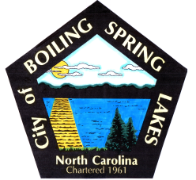 | City of Boiling Spring Lakes  9 East Boiling Spring Road  Boiling Spring Lakes, NC 28461

Special Events Committee
November 12, 2025
5:30 P.M.
City Hall

AGENDA

- Call to Order

- Approval of Agenda

- Approval of Minutes

- Public Comment

- Budget Report

- Old Business

a. Recap Halloween Fall Festival
b. Recap Candidates Forum
c. City Christmas Tree Lighting
d. Christmas

- New Business

- Donation

- EAnnouncements

- Next Meeting Agenda Items

- Adjournment

