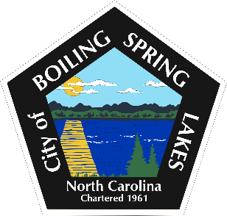

City of Boiling Spring Lakes
Citizen's Forum
Thursday, September 18, 2025 6:00 P.M.
City Hall

- Call to Order
- Pledge of Allegiance
- Approval of the Agenda
- Citizen’s Forum
- Adjourn

