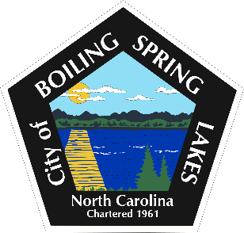

City of Boiling Spring Lakes
Citizen's Forum
Thursday, June 19, 2025 6:00 P.M.
City Hall

- Call to Order- Mayor Pro Tem David Mammay
- Pledge of Allegiance
- Approval of the Agenda
- Citizen’s Forum
- Adjourn

