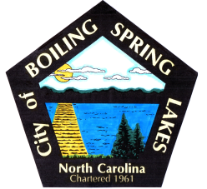 | City of Boiling Spring Lakes  9 East Boiling Spring Road  Boiling Spring Lakes, NC 28461

Library Commission
City Hall
March 12, 2026
AGENDA

I. CALL TO ORDER
II. APPROVAL OF AGENDA
III. APPROVAL OF MINUTES
IV. PUBLIC COMMENT
V. OLD BUSINESS
A. Status of library preparation
- Plans for grand opening scheduled for April 18

VI. NEW BUSINESS
- Patron library cards
- Inventory labels

VII. PURCHASES & DONATIONS & BUDGET REVIEW
VIII. ANNOUNCEMENTS
IX. NEXT MEETING AGENDA ITEMS

X. ADJOURNMENT

