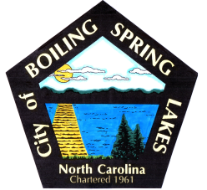 | City of Boiling Spring Lakes  9 East Boiling Spring Road  Boiling Spring Lakes, NC 28461

Library Commission
City Hall
February 12, 2026
AGENDA

I. CALL TO ORDER
II. APPROVAL OF AGENDA
III. APPROVAL OF MINUTES
IV. PUBLIC COMMENT
V. OLD BUSINESS
A. Update on Renovation
B. Workshop Overview
C. Additional money requested

VI. NEW BUSINESS
VII. PURCHASES & DONATIONS & BUDGET REVIEW
VIII. ANNOUNCEMENTS
IX. NEXT MEETING AGENDA ITEMS

X. ADJOURNMENT

