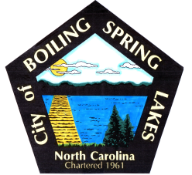 | City of Boiling Spring Lakes  9 East Boiling Spring Road  Boiling Spring Lakes, NC 28461

Library Commission
Boiling Spring Lakes City Hall
January 8, 2026, 9:30AM
AGENDA

I. CALL TO ORDER

II. APPROVAL OF AGENDA

III. APPROVAL OF MINUTES

IV. PUBLIC COMMENT

V. OLD BUSINESS
A. Update on renovation of new space
- Plan workshops for opening new space

VI. NEW BUSINESS

VII. PURCHASES & DONATIONS & BUDGET REVIEW

VIII. ANNOUNCEMENTS

IX. NEXT MEETING AGENDA ITEMS

X. ADJOURNMENT

