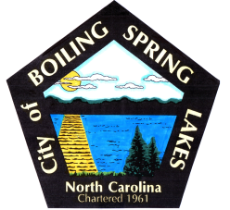 | City of Boiling Spring Lakes  9 East Boiling Spring Road  Boiling Spring Lakes, NC 28461

Library Commission
Boiling Spring Lakes City Hall
December 11, 2025, 9:30AM
AGENDA

I. CALL TO ORDER

II. APPROVAL OF AGENDA

III. APPROVAL OF MINUTES

IV. PUBLIC COMMENT

V. OLD BUSINESS
A. Update on renovation of new space
B. Status of new equipment purchases

VI. NEW BUSINESS
- Welcome new liaison Todd Ausborn
- Welcome new commission member Sylvia Varnell
- Project plan for opening of new library
- Discuss accounting for future donations
- FY26 budget review
  - Library budget
  - Library grant expenditures
- Discussion of future purchase of paperback books

VII. PURCHASES & DONATIONS & BUDGET REVIEW

VIII. ANNOUNCEMENTS

IX. NEXT MEETING AGENDA ITEMS

X. ADJOURNMENT

