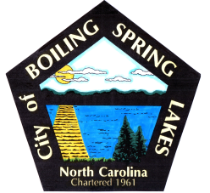 | City of Boiling Spring Lakes  9 East Boiling Spring Road  Boiling Spring Lakes, NC 28461

Library Commission
Boiling Spring Lakes City Hall
August 14, 2025, 9:30AM
AGENDA

I. CALL TO ORDER

II. APPROVAL OF AGENDA

III. APPROVAL OF MINUTES

IV. PUBLIC COMMENT

V. OLD BUSINESS
A. Update on renovation of new space
B. Library Purchases

VI. NEW BUSINESS

VII. PURCHASES & DONATIONS & BUDGET REVIEW

VIII. ANNOUNCEMENTS

IX. NEXT MEETING AGENDA ITEMS

X. ADJOURNMENT

