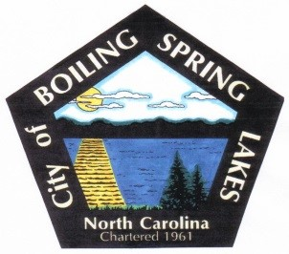
City of Boiling Spring Lakes
Planning Board
November 14, 2023
City Hall – 6:30 P.M.

AGENDA

- Call to Order

- Pledge of Allegiance

- Roll Call

- Approval of Agenda

- Approval of Minutes

  - October 17, 2023

- Public Comment

- Old Business

  - None

- New Business

    - Discussion – City Center
    - Discussion – General UDO Updates

- Other Business

- Announcements

- Adjourn

