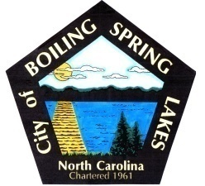 | City of Boiling Spring Lakes  9 East Boiling Spring Road  Boiling Spring Lakes, NC 28461

Parks and Recreation Advisory Board
Wednesday, October 18th, 2023
6:00 P.M.

AGENDA

I. Call to Order

II. Introductions

III. Approval of Agenda

IV. Approval of Minutes

V. Director’s Monthly Report

VI. Committee Selection & Reports

VII. Public Comments

VIII. Old Business
A. 501c 3 Update
B. Extended an offer for the senior coordinator position
C. Claudia buried all the mats at Muse Park.
D. The park concerns that Steven had have been addressed and sent to PW.
E. Claudia took care of the table at SLP that was not where it was supposed to be.

IX. New Business

X. Next Meeting Agenda Items

XI. Announcements

XII. Adjournment

