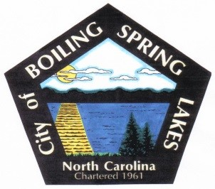
City of Boiling Spring Lakes
Community Appearance Commission
August 14, 2023
City Hall – 6:00 pm

AGENDA

- Call to Order

- Attendance and welcome new members

- Approval of Agenda

- Approval of August 14th Meeting Minutes

- Public Comments

- Old Business

- Financial report. $1,000 budget. Expenditures? Were chip clips ordered? Balance?
- Finalize welcome bag delivery
- Report on Property violations

- New Business
- Resources
- Solicitation for prizes for Halloween and Christmas recognition
- Yellow book delivery
- Safety Protocals

- Comments and Announcements
Kathryn and Barbara are attending the Planning Board meeting tomorrow night to present the native plant proposal, join us if you can at 5:30

- BOC Report:
October Tom
November, Barbara
December, Kevin
January, Shellie
February, Randy
March, Kathryn
April, Paul
- Adjournment

