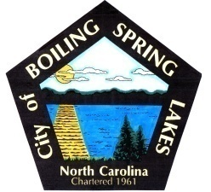 | City of Boiling Spring Lakes  9 East Boiling Spring Road  Boiling Spring Lakes, NC 28461

Parks and Recreation Advisory Board
Wednesday, September 27th, 2023
6:00 P.M.

AGENDA

I. Call to Order

II. Introductions

III. Approval of Agenda

IV. Approval of Minutes

V. Director’s Monthly Report

VI. Committee Selection & Reports

VII. Public Comments

VIII. Old Business
A. Friends of P&R 501c3 Update
B. Clean Sweep
C. Trunk or Treat
D. (1) AS position and (1) Senior Coordinator Position Open
E. BoC meeting for October is Steven D

IX. New Business
A. Learning Garden
*PW cannot do much with it and those with beds cannot do it all either
B. Pancake Breakfast

X. Next Meeting Agenda Items

XI. Announcements

XII. Adjournment

