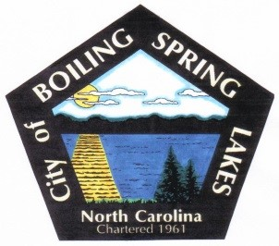
City of Boiling Spring Lakes
Community Appearance Commission
August 14, 2023
City Hall – 6:00 pm

AGENDA

- Call to Order

- Attendance and welcome new members

- Approval of Agenda

- Approval of July 10th Meeting Minutes

- Public Comments

- Old Business

- Financial report. $1,000 budget. Expenditures? Were chip clips ordered? Balance?
- Confirm how welcome bags will be distributed and request public notice for this
- Review City Property list, (Ruth)
- Tree removal program, Tom
- Review and approve property recognition rules
- BOC Report:
September, Paul
October Tom
Novemeber, Barbara
December, Kevin
January, Shellie
February, Randy
March, Kathryn

- New Business
- Review report on property violations based on Code Enforcement list of open complaints
Report on what has been done. (Ruth)
- Political signs?
- Old fire station building. What lies in the future for this building?

- Comments from members

- Adjournment

