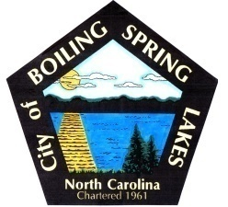 | City of Boiling Spring Lakes  9 East Boiling Spring Road  Boiling Spring Lakes, NC 28461

Parks and Recreation Advisory Board
Wednesday, August 16, 2023
6:00 P.M.

AGENDA

I. Call to Order

II. Approval of Agenda

III. Approval of Minutes

IV. Old Business
a. Lake Ordinance and Wake Regulation
b. Friends Group
c. Report at BOC Meeting (review and remind)

V. Public Comment

VI. New Business
a. Parks & Recreation Monthly Department Report
b. Subcommittee Reports and Goals
- Facilities, Communications and Department Subcommittees
c. Seniors 100% recapture on fees
d. (2) After school positions (part time) and (1) Program Asst Position (full time) open

VII. Next Meeting Agenda Items

VIII. Announcements

IX. Adjournment

