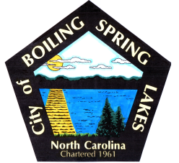 | City of Boiling Spring Lakes  9 East Boiling Spring Road  Boiling Spring Lakes, NC 28461

Grants Committee
Meeting Agenda
May 25, 2022
5:30 P.M.
City Hall

- Call to Order
- Approval of Agenda
- Review Grants discussed last meeting
  - Golden LEAF
  - Orton Plantation
  - Generator Grants
- New Grant Opportunities
  - Duke Energy
  - Generator grants
- Grant Research Assignments
- Adjourn

