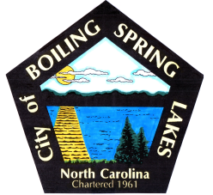 | City of Boiling Spring Lakes  9 East Boiling Spring Road  Boiling Spring Lakes, NC 28461

Grants Committee
Meeting Agenda
May 10, 2022
3:00 P.M.
City Hall Administrative Conference Room

- Call to Order
- Approval of Agenda
- Introduce new members
- Review Grants discussed last meeting
  - Golden LEAF
  - TIRF – Transportation Infrastructure Resiliency Fund
  - DRM – Disaster Resiliency Mitigation
  - Community Direct Funding
- New Grant Opportunities
  - Orton Plantation
  - Generator grants
- Project Review and Prioritization
- Grant Research Assignments
- Discussion of changing meeting day and time
- Adjourn

