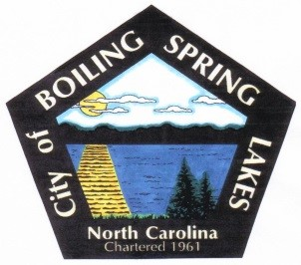
City of Boiling Spring Lakes
Community Appearance Commission
April 10, 2023
City Hall – 6:00 pm

AGENDA

- Call to Order

- Roll Call

- Approval of Agenda

- Public Comment

- Old Business

Approval of March 13 minutes

- New Business

- Appointment of representative(s) for Technical Review Committee

- Selection of person/schedule to do report to Board of Commissioners

- Review of Welcome bags and Yard winner responsibilities.

- Comments from members

- Adjournment

