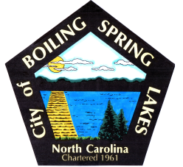 | City of Boiling Spring Lakes  9 East Boiling Spring Road  Boiling Spring Lakes, NC 28461

Grants Committee
Meeting Agenda
April 12, 2022
3:30 P.M.
City Hall Administrative Conference Room

- Call to Order
- Approval of Agenda
- Review Grants discussed last meeting
  - Golden LEAF
  - TIRF – Transportation Infrastructure Resiliency Fund
  - DRM – Disaster Resiliency Mitigation
- New Grant Opportunities
  - Main Street Grants
  - Community Project Funding
- Project Review and Prioritization
- Grant Research Assignments
- Discussion of increasing committee to 5 members
- Adjourn

