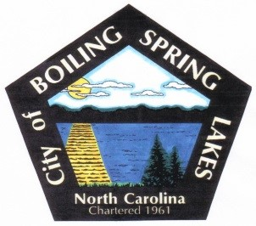
City of Boiling Spring Lakes
Community Appearance Commission
March 13, 2023
City Hall – 6:00 pm

AGENDA

- Call to Order

- Roll Call

- Approval of Agenda

- Public Comment

- Old Business

  - Election of Officers – Chairman, Vice-Chairman, and Secretary
    - Nominations from members for the positions
    - Motions and voting
Newly elected officers now take seats and assume responsibility for duties

- New Business

- Recommendation to amend Chapter 2 Article III. – Boards, Committees and Commissions, Division 3. – Community Appearance Commission, Section 2.84. – Powers and Duties of the City Ordinances.

- Recommendation to amend Chapter 4 – Buildings and Building of the City Ordinances by adding Article VI. – Minimum Housing Code Regulation

- Garden at Spring Lake Park

- Founder’s Day volunteers needed

- Adjournment

