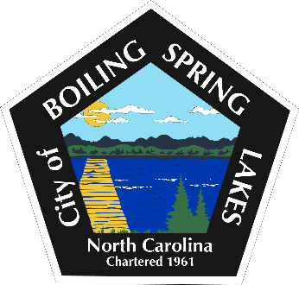
Board of Commissioners
Monday, January 26, 2026
Establishing Goals for FY 2027

- Call to Order- Mayor Jeff Winecoff
- Approval of the Agenda
- Establishing Goals for the FY 2027
- Adjourn

