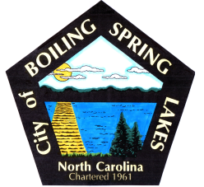 | City of Boiling Spring Lakes  9 East Boiling Spring Road  Boiling Spring Lakes, NC 28461

Community Appearance Commission
January 17, 2023
5:00 PM

AGENDA

1. Call to Order

2. Approval of Regular Agenda

3. Old Business
a. Meeting Schedule

4. New Business
a. Member Introductions
b. Election of Chairperson
c. Election of Vice Chairperson
d. Election of Secretary (takes minutes)

5. Discussion
a. Expectations of Commission
b. Review of Ordinance and Statute

6. Adjournment

